**Assignment 5**

1. **Problem Statement**
   1. **Chandy-Lamport’s Algorithm for Global State Recording**
2. **Source Code**
   1. **>> Main. java**

/* ABOUT PROJECT

* This project demonstrates the Chandy-Lamport's global state recording algorithm

* using threads to record the global state of distributed systems.

*/

/* ABOUT MAIN CLASS

* The Main class serves as the core orchestrator for a simulation of distributed systems

* using the Chandy-Lamport's global state recording algorithm in Java.

* It begins by importing necessary libraries for file handling, UI interactions, and data structures.

* The main method initializes essential components such as lists for managing threads and nodes,

* and a Channel object for communication. Through a file dialog, users select a file containing

* the graph structure of the distributed system, which is then parsed by the Graph class.

* After prompting the user to specify an initiator node, the program validates this choice against

* the graph and proceeds to create and manage threads for each node. Threads are started for both

* the initiator and other nodes, with synchronization ensuring proper message exchange and state recording.

* Upon completion of thread execution, the program outputs a global snapshot, detailing the

* messages exchanged and current states of each node and the communication channels.

* Finally, the program gracefully exits, providing a comprehensive demonstration of the

* Chandy-Lamport's algorithm application in distributed system simulation.

*/

/* ABOUT AUTHOR

Rahul Biswas, Arijit Mondal

*/

import java.awt.FileDialog;

import java.awt.Frame;

import java.util.ArrayList;

import java.util.HashMap;

import java.util.LinkedList;

import java.util.List;

import java.util.Map;

import java.util.Queue;

import javax.swing.JOptionPane;

public class Main {

public static void main(String[] args) {

// Lists to keep track of threads and nodes

List<Thread> threads = new LinkedList<>();

List<Node> nodes = new LinkedList<>();

Channel channel = new Channel(); // Shared communication channel

// Open file dialog to select a file

String filePath = openFileDialog();

if (filePath == null) {

System.out.println("No file selected");

System.exit(0);

}

// Create graph from the file

Graph graph = new Graph(filePath);

// Get initiator name from the user

String initiator = JOptionPane.showInputDialog("Enter initiator:");

// Validate initiator and get node connections

Map<String, List<String>> nodeNames = graph.checkInitiator(initiator);

if (nodeNames != null) {

System.out.println();

System.out.println("System Log ::::\n");

// Create the initiator node and start its thread

Node node = new Node(initiator, channel, nodeNames.get(initiator));

Thread thread = new Thread(node);

nodes.add(node);

threads.add(thread);

thread.start(); // Start the initiator thread

node.setInitiatorStatus(); // Set the node as the initiator

System.out.println("Information Message :: " + initiator + " is now initiator");

// Pause for a short duration to ensure initiator starts

try {

Thread.sleep(500);

} catch (InterruptedException e) {

e.printStackTrace();

}

// Create and start threads for all other nodes

for (String name : nodeNames.keySet()) {

if (!name.equals(initiator)) {

Node n = new Node(name, channel, nodeNames.get(name));

Thread t = new Thread(n);

nodes.add(n);

threads.add(t);

t.start(); // Start thread for each node

}

}

// Wait for all threads to finish

for (Thread td : threads) {

try {

td.join();

} catch (InterruptedException e) {

e.printStackTrace();

}

}

// Print global snapshot of the system

System.out.println();

System.out.println("Global Snapshot ::::");

for (Node n : nodes) {

System.out.println("\nLocal State Recording of " + n.getName() + " ::");

System.out.println("-->Messages delivered: ");

HashMap<String, List<String>> sendMessage = n.getSendMessages();

if (!sendMessage.isEmpty()) {

for (Map.Entry<String, List<String>> sendMessages : sendMessage.entrySet()) {

String key = sendMessages.getKey();

List<String> values = sendMessages.getValue();

System.out.print("To: " + key + " { ");

for (int i = 0; i < values.size(); i++) {

System.out.print(values.get(i));

if (i < values.size() - 1) {

System.out.print(" , ");

}

}

System.out.println(" }");

}

} else {

System.out.println("NONE");

}

System.out.println("-->Messages received: ");

HashMap<String, List<String>> receivedMessage = n.getReceivedMessages();

if (!receivedMessage.isEmpty()) {

for (Map.Entry<String, List<String>> receivedMessages : receivedMessage.entrySet()) {

String key = receivedMessages.getKey();

List<String> values = receivedMessages.getValue();

System.out.print("From: " + key + " { ");

for (int i = 0; i < values.size(); i++) {

System.out.print(values.get(i));

if (i < values.size() - 1) {

System.out.print(" , ");

}

}

System.out.println(" }");

}

} else {

System.out.println("NONE");

}

}

// Print communication channel state

System.out.println("\nCommunication Channel State ::");

HashMap<String, Queue<String>> communicationChannel = channel.getCommunicationChannel();

for (Map.Entry<String, Queue<String>> specificChannel : communicationChannel.entrySet()) {

String receiverName = specificChannel.getKey();

HashMap<String, List<String>> tempHashMap = new HashMap<>();

Queue<String> tempQueue = specificChannel.getValue();

for (String message : tempQueue) {

String[] splitMessage = message.split(":");

String senderName = splitMessage[0];

String messageContentType = splitMessage[1];

if (messageContentType.equalsIgnoreCase("TEXT")) {

if (tempHashMap.containsKey(senderName)) {

tempHashMap.get(senderName).add(splitMessage[2]);

} else {

List<String> tempList = new ArrayList<>();

tempList.add(splitMessage[2]);

tempHashMap.put(senderName, tempList);

}

}

}

for (Map.Entry<String, List<String>> tempNode : tempHashMap.entrySet()) {

String senderName = tempNode.getKey();

List<String> values = tempNode.getValue();

System.out.print("\n Channel :: " + senderName + " -- " + receiverName + " : { ");

for (int i = 0; i < values.size(); i++) {

System.out.print(values.get(i));

if (i < values.size() - 1) {

System.out.print(" , ");

}

}

System.out.println(" }");

}

}

System.exit(0); // Exit program after printing snapshot

} else {

// If initiator is not valid

System.out.println("Please choose another initiator!!");

System.exit(0);

}

}

// Method to open file dialog and get the selected file path

public static String openFileDialog() {

FileDialog fd = new FileDialog((Frame) null, "Open", FileDialog.LOAD);

fd.setVisible(true); // Display file dialog

String directory = fd.getDirectory();

String file = fd.getFile();

if (directory != null && file != null) {

return directory + file; // Return full path of the selected file

}

return null; // Return null if no file was selected

}

}

* 1. **>> Node. java**

/*ABOUT NODE CLASS

* The Node class in Java models a system or process within a distributed environment,

* designed to communicate with neighboring nodes via a shared Channel.

* Each Node instance runs in its own thread (Runnable), implementing

* logic to send and receive messages, manage message types (TEXT or MARKER),

* and maintain message histories (sendMessages and receivedMessages).

* Key attributes include its name, neighbor nodes list, initiator status (isInitiator),

* and a random number generator for message scheduling. The class supports dynamic

* behavior where nodes can act as initiators, exchange messages, and react to incoming

* marker messages to record global states in distributed systems scenarios.

*/

import java.util.HashMap;

import java.util.LinkedList;

import java.util.List;

import java.util.Random;

public class Node implements Runnable {

private String name; // Name of the node

private Channel channel; // Communication channel for the node

private List<String> neighbor; // List of neighboring nodes

private Boolean isInitiator = false; // Flag to check if the node is the initiator

private Random random = new Random(); // Random number generator for message sending

private MessageType messageType = MessageType.TEXT; // Type of message (TEXT or MARKER)

private HashMap<String, List<String>> sendMessages = new HashMap<>(); // Messages sent by this node

private HashMap<String, List<String>> receivedMessages = new HashMap<>(); // Messages received by this node

private int markerSendCounter = 3; // Counter to control marker message sending

// Constructor to initialize the node

public Node(String name, Channel channel, List<String> neighbor) {

this.name = name;

this.channel = channel;

this.neighbor = neighbor;

}

// Main logic of the node, to be executed in a separate thread

@Override

public synchronized void run() {

while (!Thread.currentThread().isInterrupted()) {

try {

// If the node is the initiator, choose the type of message to send

if (isInitiator)

messageTypeChooser();

// Decide whether to send a message based on random chance

int willSend = random.nextInt(10 + 1);

if (messageType == MessageType.MARKER || willSend < 8)

sendMessage();

// If the thread is not interrupted, wait for a random period and then receive a

// message

if (!Thread.currentThread().isInterrupted()) {

delay(random.nextInt(500) + 1);

receivedMessage();

delay(random.nextInt(500) + 1);

}

} catch (Exception e) {

e.printStackTrace();

}

}

}

// Set the initiator status for the node

public void setInitiatorStatus() {

isInitiator = true;

}

// Get the messages sent by this node

public HashMap<String, List<String>> getSendMessages() {

return sendMessages;

}

// Get the messages received by this node

public HashMap<String, List<String>> getReceivedMessages() {

return receivedMessages;

}

// Get the name of the node

public String getName() {

return name;

}

// Method to send a message to a random neighbor

private void sendMessage() {

if (messageType == MessageType.MARKER) {

// If the message type is MARKER, send it to all neighbors

for (String receiverName : neighbor) {

String message = messageGenerator(null, receiverName);

System.out.println("Send Marker :: " + name + " is sending " + " marker " + " to " + receiverName);

System.out.println("----------------------------------------------------------------");

channel.deliver(message);

}

// Interrupt the thread after sending marker messages

Thread.currentThread().interrupt();

} else if (!neighbor.isEmpty()) {

// If the message type is TEXT, send it to a random neighbor

int randomIndex = random.nextInt(neighbor.size());

String receiverName = neighbor.get(randomIndex);

String messageContent = String.valueOf(random.nextInt(100));

String message = messageGenerator(messageContent, receiverName);

// Update the sent messages map

if (sendMessages != null && sendMessages.keySet() != null) {

boolean exists = sendMessages.keySet().stream()

.anyMatch(k -> k.equalsIgnoreCase(receiverName));

if (exists) {

List<String> temp = sendMessages.get(receiverName);

if (temp != null) {

temp.add(messageContent);

} else {

temp = new LinkedList<>();

temp.add(messageContent);

}

sendMessages.put(receiverName, temp);

} else {

List<String> temp = new LinkedList<>();

temp.add(messageContent);

sendMessages.put(receiverName, temp);

}

} else {

List<String> temp = new LinkedList<>();

temp.add(messageContent);

sendMessages.put(receiverName, temp);

}

System.out.println("Send Message :: " + name + " is sending " + messageContent + " to " + receiverName);

channel.deliver(message);

}

}

// Method to receive a message from the channel

private void receivedMessage() {

String message = channel.receive(name);

if (message != null) {

String[] messageContent = message.trim().split(":");

// If the received message is a MARKER, update the message type and send marker

// messages

if (messageContent[1].equals("MARKER")) {

System.out.println(

"Received Marker :: " + name + " is received a marker from " + " from " + messageContent[0]);

messageType = MessageType.MARKER;

sendMessage();

} else {

// If the received message is a TEXT, update the received messages map

if (receivedMessages != null && receivedMessages.keySet() != null) {

boolean exists = receivedMessages.keySet().stream()

.anyMatch(k -> k.equalsIgnoreCase(messageContent[0]));

System.out.println("Received Message :: " + name + " received a message " + messageContent[2]

+ " from " + messageContent[0]);

if (exists) {

List<String> temp = receivedMessages.get(messageContent[0]);

if (temp != null) {

temp.add(messageContent[2]);

} else {

temp = new LinkedList<>();

temp.add(messageContent[2]);

}

receivedMessages.put(messageContent[0], temp);

} else {

List<String> temp = new LinkedList<>();

temp.add(messageContent[2]);

receivedMessages.put(messageContent[0], temp);

}

} else {

List<String> temp = new LinkedList<>();

temp.add(messageContent[2]);

receivedMessages.put(messageContent[0], temp);

}

}

}

}

// Method to choose the type of message to send (TEXT or MARKER)

private void messageTypeChooser() {

if (markerSendCounter <= 0) {

int chooser = random.nextInt(10);

if (chooser < 8)

messageType = MessageType.TEXT;

else

messageType = MessageType.MARKER;

} else {

markerSendCounter--;

}

}

// Method to generate a message string with the given content and receiver name

private String messageGenerator(String messageContent, String receiverName) {

String message;

message = name + ":" + messageType + ":" + messageContent + ":" + receiverName;

return message;

}

// Method to introduce a delay (in milliseconds) in the thread execution

private void delay(int miliSec) throws InterruptedException {

if (!Thread.currentThread().isInterrupted())

Thread.sleep(miliSec);

}

}

* 1. **>> Graph. java**

/*ABOUT GRAPH CLASS

The Graph class in Java encapsulates functionality for managing a directed graph

using an adjacency list data structure. It initializes with a specified file path

to populate its adjacency list, reading node connections and handling cases

where nodes have no neighbors or are connected to a null node. Methods include

adding edges between nodes, printing the graph's adjacency list representation,

and performing a Breadth-First Search (BFS) to check graph connectivity from a

specified initiator node. It offers utility for applications needing to analyze

and manipulate graph structures, particularly in scenarios involving distributed

systems or network topologies where connectivity and node relationships are crucial

for system behavior and analysis.

*/

import java.io.File;

import java.util.ArrayList;

import java.util.Arrays;

import java.util.HashMap;

import java.util.List;

import java.util.Map;

import java.util.Scanner;

public class Graph {

private String filePath; // Path to the file containing the graph data

private Map<String, List<String>> adjacencyList = new HashMap<>(); // Adjacency list to store the graph

// Constructor to initialize the graph with the file path

public Graph(String filePath) {

this.filePath = filePath;

populateAdjacencyList(); // Populate the adjacency list with data from the file

}

// Method to read the file and populate the adjacency list

private void populateAdjacencyList() {

try {

File file = new File(filePath); // Open the file

Scanner scanner = new Scanner(file); // Scanner to read the file

// Read the file line by line

while (scanner.hasNextLine()) {

String line = scanner.nextLine().trim(); // Read and trim each line

if (line.isEmpty()) {

continue; // Skip empty lines

}

String[] parts = line.split("->"); // Split the line into source and destination nodes

String src = parts[0].trim(); // Source node

// If there are destination nodes, add them to the adjacency list

if (parts.length > 1) {

for (int i = 1; i < parts.length; i++) {

String dest = parts[i].trim(); // Destination node

if (dest.equalsIgnoreCase("null"))

addEdge(src, null); // Add edge with null destination

else

addEdge(src, dest); // Add edge with valid destination

}

} else {

addEdge(src, null); // Handle case with only source node

}

}

scanner.close(); // Close the scanner

printGraph(); // Print the adjacency list representation of the graph

} catch (Exception e) {

System.out.println("Error reading file: " + e.getMessage()); // Handle file reading errors

}

}

// Method to add an edge to the adjacency list

private void addEdge(String src, String dest) {

adjacencyList.putIfAbsent(src, new ArrayList<>()); // Add source node if not already present

if (dest != null) {

adjacencyList.get(src).add(dest); // Add destination node to the adjacency list of the source node

}

}

// Method to print the adjacency list representation of the graph

private void printGraph() {

System.out.println();

System.out.println("Graph Information :::: ");

System.out.println();

System.out.println("Inserted Graph (Adjacency List Representation) :");

for (Map.Entry<String, List<String>> entry : adjacencyList.entrySet()) {

System.out.print(entry.getKey() + " -> "); // Print source node

List<String> neighbors = entry.getValue(); // Get list of neighbors

if (!neighbors.isEmpty()) {

for (int i = 0; i < neighbors.size(); i++) {

System.out.print(

neighbors.get(i) != null ? (neighbors.get(i).equals("null") ? "null" : neighbors.get(i)): "NULL"); // Print each neighbor

if (i != neighbors.size() - 1) {

System.out.print(", "); // Print comma if not the last neighbor

}

}

} else {

System.out.print("null"); // Print null if no neighbors

}

System.out.println();

}

}

// Method to perform BFS and check if the graph is connected from the initiator

// node

private Boolean bfsForAdjacencyList(String initiator) {

int noOfNodes = adjacencyList.size(); // Number of nodes in the graph

boolean[] visited = new boolean[noOfNodes]; // Array to keep track of visited nodes

Arrays.fill(visited, false); // Initialize all nodes as not visited

List<String> q = new ArrayList<>();

q.add(initiator); // Add initiator to the queue

visited[getIndex(initiator)] = true; // Mark initiator as visited

// Perform BFS

while (!q.isEmpty()) {

String current = q.remove(0); // Dequeue a node

List<String> neighbors = adjacencyList.get(current); // Get neighbors of the current node

if (neighbors != null) {

for (String neighbor : neighbors) {

if (!visited[getIndex(neighbor)]) {

q.add(neighbor); // Add unvisited neighbors to the queue

visited[getIndex(neighbor)] = true; // Mark neighbor as visited

}

}

}

}

// Check if all nodes were visited

for (int i = 0; i < noOfNodes; i++) {

if (!visited[i]) {

return false; // If any node is not visited, return false

}

}

return true; // Return true if all nodes were visited

}

// Method to get the index of a vertex in the adjacency list

private int getIndex(String vertex) {

int index = 0;

for (String key : adjacencyList.keySet()) {

if (key.equals(vertex)) {

return index; // Return the index if vertex matches

}

index++;

}

return index; // Return the index

}

// Method to check if the initiator can be a valid starting node for BFS

public Map<String, List<String>> checkInitiator(String initiator) {

boolean exists = adjacencyList.keySet().stream().anyMatch(k -> k.equalsIgnoreCase(initiator)); // Check if initiator exists in the graph

if (exists) {

if (bfsForAdjacencyList(initiator)) {

System.out.println(initiator + " Can be an initiator."); // Print if initiator is valid

return adjacencyList; // Return adjacency list

} else {

System.out.println(initiator + " Cannot be an initiator."); // Print if initiator is not valid

return null;

}

} else {

System.out.println("Node does not exist in the adjacency list. Please check"); // Print if initiator does not exist

return null;

}

}

}

* 1. **>> Channel. java**

/*ABOUT CHANNEL CLASS

* The Channel class in Java represents a communication channel between

* nodes in a distributed system. It uses a HashMap to manage communication

* queues (Queue<String>) for each receiver node. Messages can be delivered

* (deliver) to a specific receiver's queue based on the message content,

* and messages can be received (receive) from a particular receiver's queue.

* The class ensures that messages are queued appropriately and retrieved in

* a FIFO manner. Additionally, it provides a method (getCommunicationChannel)

* to access the entire communication channel map, useful for debugging or logging

* purposes in distributed system simulations or implementations. This class

* facilitates asynchronous communication between nodes, essential for exchanging

* messages and maintaining synchronization in distributed environments.

*/

import java.util.HashMap;

import java.util.LinkedList;

import java.util.Queue;

public class Channel {

// HashMap to store communication channels for each receiver

private HashMap<String, Queue<String>> communicationChannel = new HashMap<>();

// Method to deliver a message to the appropriate receiver's queue

public void deliver(String message) {

int lastIndex = message.lastIndexOf(":"); // Find the last occurrence of ':' in the message

String receiverName = message.substring(lastIndex + 1); // Extract receiver's name from the message

// Check if the communication channel and its keys are not null

if (communicationChannel != null && communicationChannel.keySet() != null) {

// Check if the receiver's name exists in the communication channel

boolean exists = communicationChannel.keySet().stream()

.anyMatch(k -> k.equalsIgnoreCase(receiverName));

if (exists) {

// If the receiver's queue exists, add the message to it

Queue<String> temp = communicationChannel.get(receiverName);

if (temp != null) {

temp.offer(message); // Add the message to the queue

} else {

// If the queue is null, create a new queue and add the message to it

temp = new LinkedList<>();

temp.offer(message);

}

// Update the communication channel with the receiver's queue

communicationChannel.put(receiverName, temp);

} else {

// If the receiver's queue does not exist, create a new queue and add the

// message to it

Queue<String> temp = new LinkedList<>();

temp.offer(message);

// Add the new queue to the communication channel for the receiver

communicationChannel.put(receiverName, temp);

}

} else {

// If the communication channel is null, create a new queue and add the message

// to it

Queue<String> temp = new LinkedList<>();

temp.offer(message);

// Add the new queue to the communication channel for the receiver

communicationChannel.put(receiverName, temp);

}

}

// Method to receive a message from the appropriate receiver's queue

public String receive(String receiverName) {

// Check if the receiver's name exists in the communication channel

boolean exists = communicationChannel.keySet().stream()

.anyMatch(k -> k.equalsIgnoreCase(receiverName));

if (exists) {

// Get the queue for the receiver

Queue<String> temp = communicationChannel.get(receiverName);

// If the queue is not null and not empty, poll a message from it

if (temp != null && !temp.isEmpty()) {

String message = temp.poll(); // Retrieve and remove the head of the queue

return message; // Return the message

}

}

return null; // Return null if no message is available

}

// Method to get the communication channel (for debugging or logging purposes)

public HashMap<String, Queue<String>> getCommunicationChannel() {

return communicationChannel;

}

}

* 1. **>> MessageType. java**

// Enum representing different types of messages

public enum MessageType {

// Represents a text message

TEXT,

// Represents a marker message used in distributed algorithms

MARKER

}

1. **Pre-requisites**
   1. **Java Development Kit (JDK)**: Ensure JDK is installed and properly configured on your system. This code appears to be written in Java, so JDK is essential for compiling and running Java programs.
   2. **Input File Format**: The input file format represents an adjacency list of a directed graph, where each line describes a node and its outgoing edges using the syntax source->destination1->destination2.... For example, in the lines A->C->E, B->A, C->B, D->A, and E->D, node A has directed edges to nodes C and E, node B has a directed edge to node A, and so on. This format allows for easy parsing and construction of a graph's adjacency list, which can be used for various graph operations like BFS for connectivity checks. In the provided Graph class, the populateAdjacencyList() method reads the file, parses each line, and constructs the adjacency list, facilitating graph algorithms and operations.

Examples of this provided in Sample Input file folder.

* 1. **Code run**: Use your IDE or command-line tools (like javac for compilation and java for execution) to compile and run the Main class. Ensure all dependencies are resolved and paths (for input files) are correctly specified.

Steps to run without any IDE:

Open terminal in Code folder. Then run these commands sequentially,

Javac -d bin src/*.java

java -cp bin Main

The program uses System.out.println() extensively for logging and displaying messages related to node processing, thread actions, and system status. Ensure the console output is clear and visible during program execution.

* 1. **Abstract Window Toolkit**: The openFileDialog() method uses FileDialog to prompt the user to select an input file. Ensure that the AWT components (FileDialog and Frame) work correctly on your system.
  2. **Node Behavior**: Each Node in the program simulates a process in a distributed system. Understand how each Node transitions through different states (Status) based on random events (setStatus() method) and interactions with other nodes (requestToken() and sendToken() methods).
  3. **Inserting Initiator Name:** To insert the initiator name in the program, ensure you have a correctly formatted input file representing the graph's adjacency list, where each line is in the format source->destination1->destination2.... At the start of the program, use the file dialog to select this graph file, which will be read and parsed to create the graph's adjacency list. When prompted, enter the name of the initiator node, ensuring it matches one of the nodes defined in the graph file. The program will validate the initiator node by checking if it exists in the graph and whether it can reach all other nodes via BFS, ensuring the initiator is a valid starting point for the Chandy-Lamport global state recording algorithm. If the initiator is valid, the program will proceed to simulate the distributed system, starting with the initiator node and performing the global state recording.

1. **Results**
2. 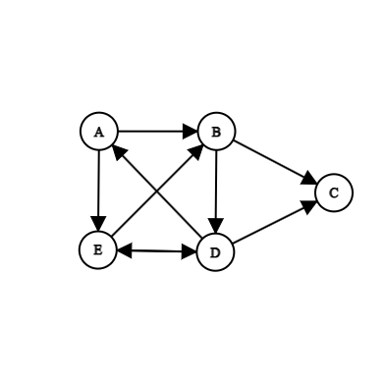
   1. **Result 1**
      1. **Input Graph**

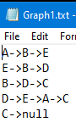

* + 1. **Input File**
    2. **Output**

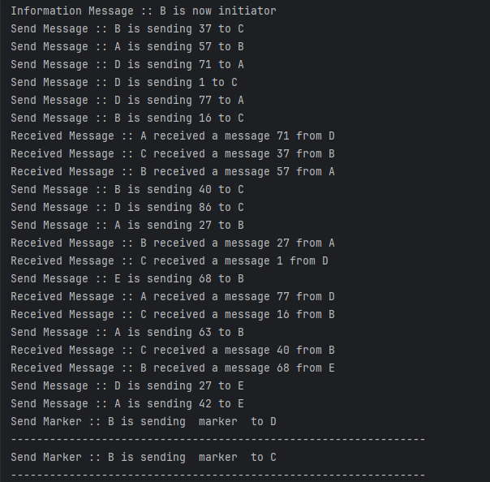

* 1. **Result 2**
     1. 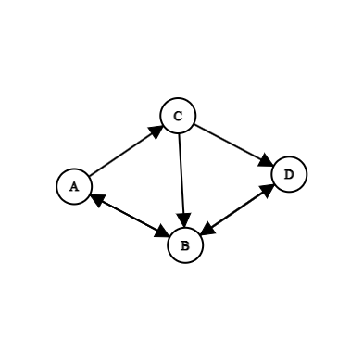**Input Graph**
     2. 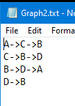**Input File**
     3. 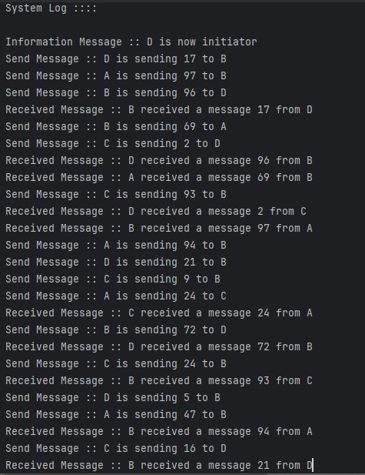**Output**
  2. **Result 3**
     1. 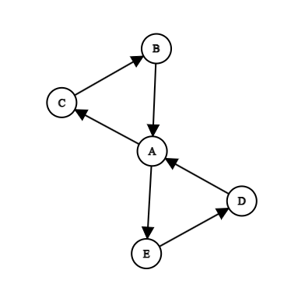**Input Graph**
     2. 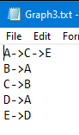**Input File**
     3. **Output**

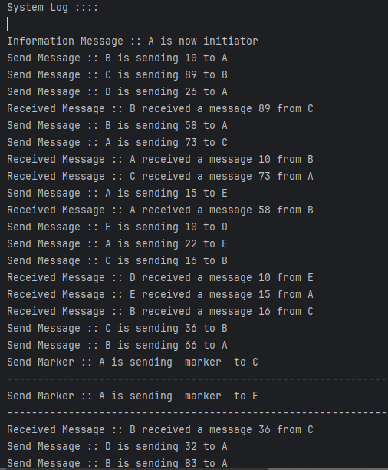

** These screenshots are part of the output log files; the complete logs are available in the output folder.

1. **Remarks**
   1. **Simulation of Distributed System**: The program simulates a distributed system using threads where each node is represented as a separate thread.
   2. **Communication Management**: A shared Channel class manages communication between nodes.
   3. **Graph Structure**: The network of nodes is defined by an adjacency list in an input file, which is crucial for the simulation.
   4. **Input File Formatting**: Correct formatting of the input file is essential for the program’s execution.
   5. **Initiator Selection**: Selecting a valid initiator node is necessary to ensure the algorithm functions correctly, as the initiator must be capable of reaching all other nodes in the graph.
   6. **Java AWT Usage**: The program uses Java AWT for file selection and input dialogs.
   7. **Message Passing and State Recording**: The program handles both message passing and global state recording effectively.
   8. **Adherence to Pre-requisites**: Ensuring proper input and adhering to defined pre-requisites are critical for demonstrating an effective simulation of the Chandy-Lamport algorithm.